Website Planning Document

Site Name and Basic Information

**Temple Inn & Suites**

Headquartered in Bethesda, MD

The overall goal of the website project is to promote and provide information about the specialized services that this hotel chain offers to meet the needs of temple patrons.

Site Purpose:

The website should reflect the Church culture and be designed to support a temple oriented theme as well as the concept of being a haven of comfort and accessibility.

**Specialized Services**

* Free access to changing rooms and bathroom facilities for temple patrons who have traveled far and need to change to and from church clothes
* A playroom and low-cost, short-term babysitting services for the children of patrons
* Long-term stay accommodations in kitchenette suites for full-time temple missionaries
* Temple history themed reception and sitting area
* A wedding reception hall that can be easily customized with a simple catering menu and kitchen access for food preparation and serving
* A family search center that supports family search and ordinance work

**Free Amenities**

* Breakfast
* Exercise/workout room
* Indoor pool
* WiFi high-speed internet access and smart TVs
* Parking
* Temple shuttle
* Family history consultation and family ordinance card service

Target Audience:

People older than 16 years old who come to serve in the temple or who participate in events such as sealings, weddings, receptions, and youth trips.

Color Scheme:

I am choosing gold background on the header and footer with gradients, since the images are going to cover most of the site view.

The text is going to be white or black depending on the background color.All the site will have a white background.

Logo

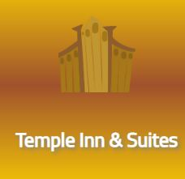

Typography:

The tittle font

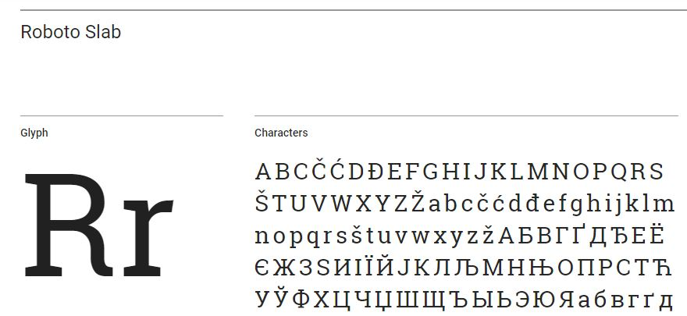

The body and comments font 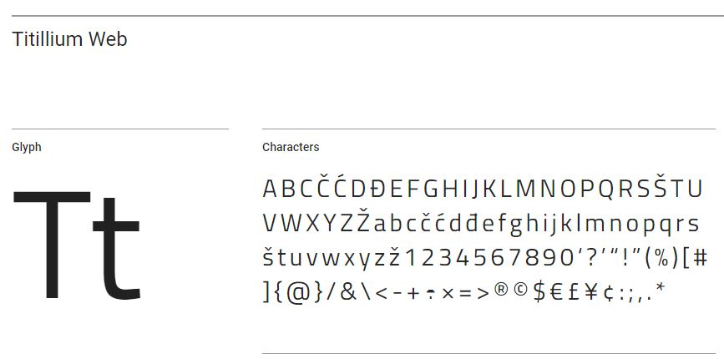

Wireframe Sketches:

Home page wireframes small

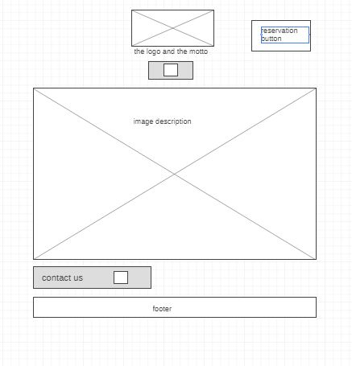

Home page wireframes medium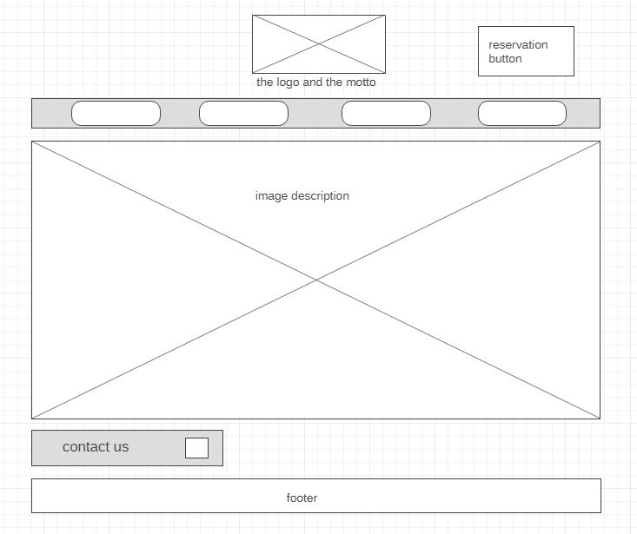

Home page wireframes large

